Tableau Lecture 6

Table of content:

| Table of content:    Agenda:  Dataset used for the class:  Table Calculation:  Understanding Various table calculations in Tableau:  Understanding Table and Pane Option in Tableau:  Business problem 1 -find percentage of total sales made per month for each year  Business problem 2-find percentage of total sales done across different categories for each quarter of the given year |
| --- |

#### Agenda:

* Quick Table Calculations
* Indexing
* Partitioning

#### Dataset used for the class:

[Sample - Superstore-Main.xlsx](https://docs.google.com/spreadsheets/d/1sM1Kjgy99k2tHBtKP5OXcpQLz7SC5yGr/edit?usp=sharing&ouid=107681937864127182413&rtpof=true&sd=true)

| **Quick Table function** | **Business Use case** |
| --- | --- |
| Running total | Sales org where they want to calculate sales till date/quarter |
| Difference | Comparative growth : year on year sales, day to day sales |
| Percent of difference | Year on year growth percentage or day to day |
| Rank | When we have to do comparison across all data points: best performing region, most revenue earning business division |
| Moving average | Metric smoothening, minimizing impact of one outlier/erroneous data point |

#### Table Calculation:

Quick table calculations allow you to quickly apply a common table calculation to your visualization using the most typical settings for that calculation type.

#### 

#### Understanding Various table calculations in Tableau:

* Step-1: Create a view by dragging category and subcategory to rows

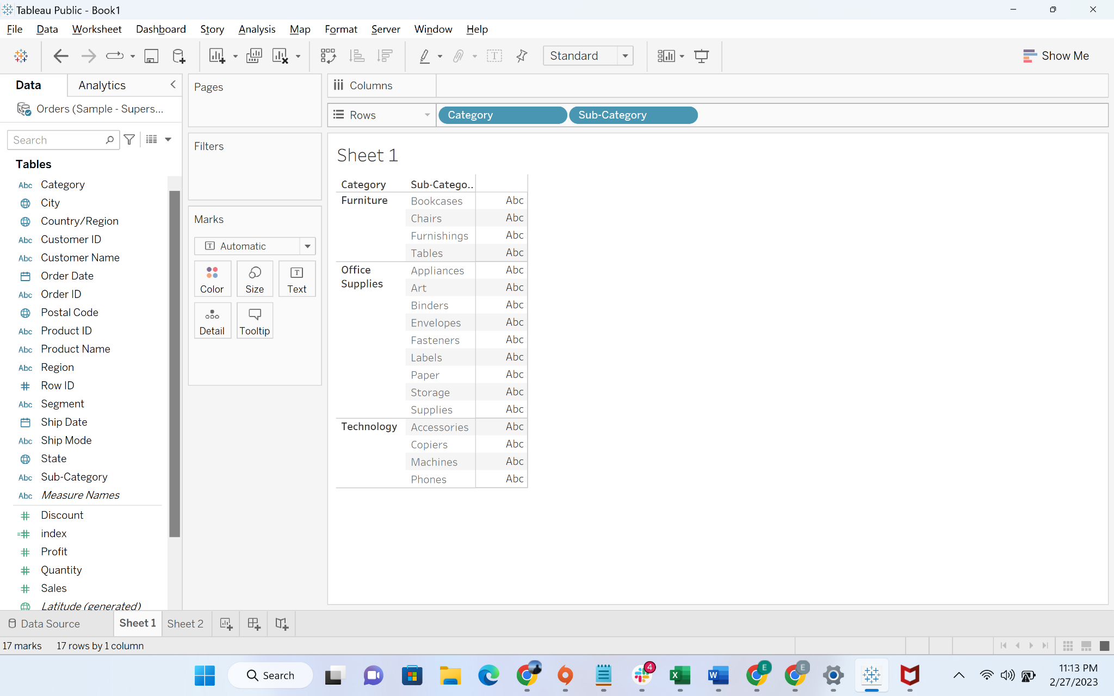

* Step-2: Drag sales to text Mark

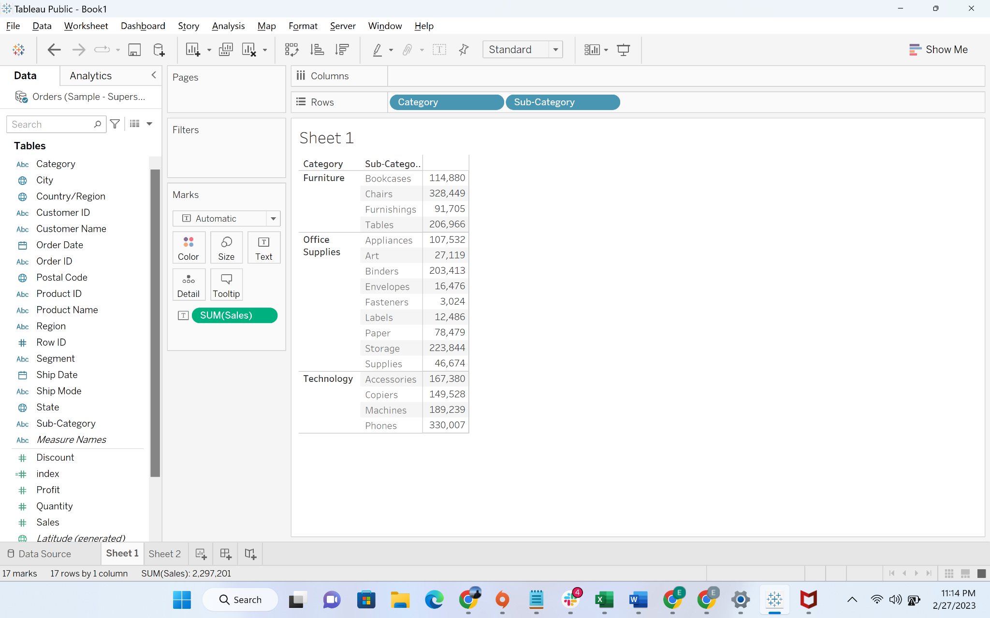

Step-3: We will now use the Quick table calculations

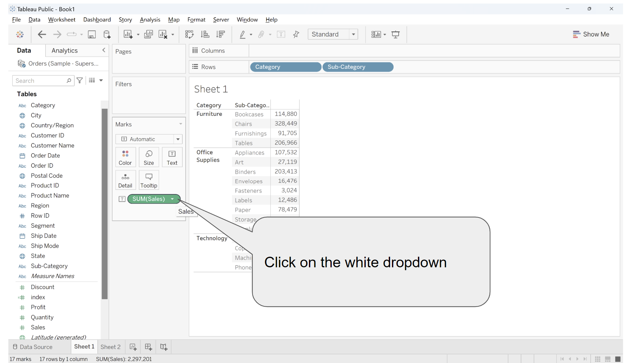

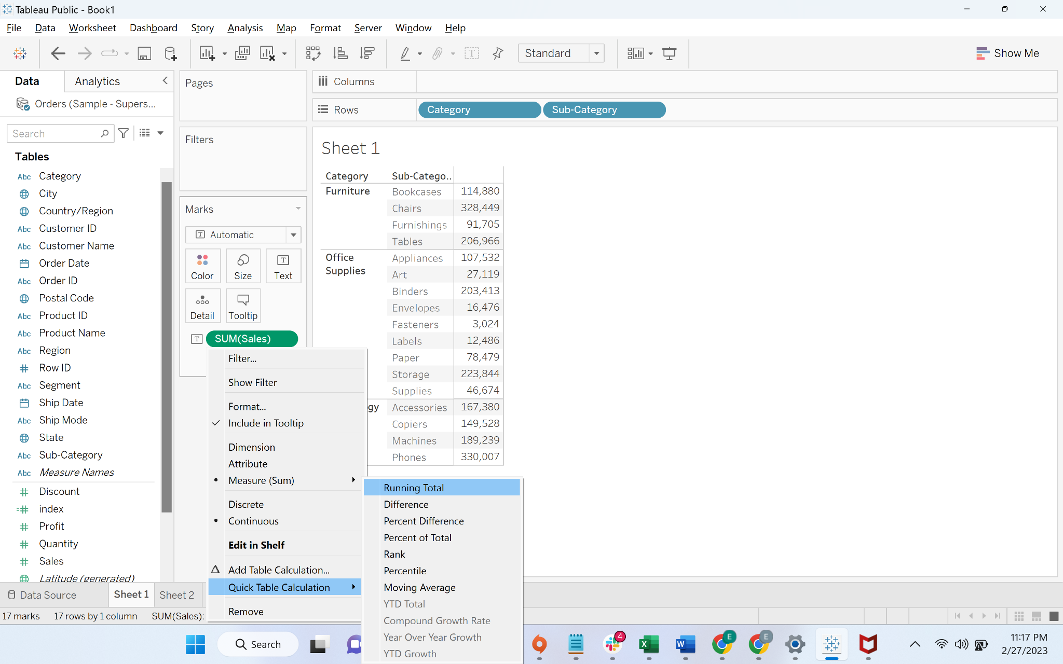

Step-3: We can now see the [cumulative SUM](https://mathworld.wolfram.com/CumulativeSum.html)

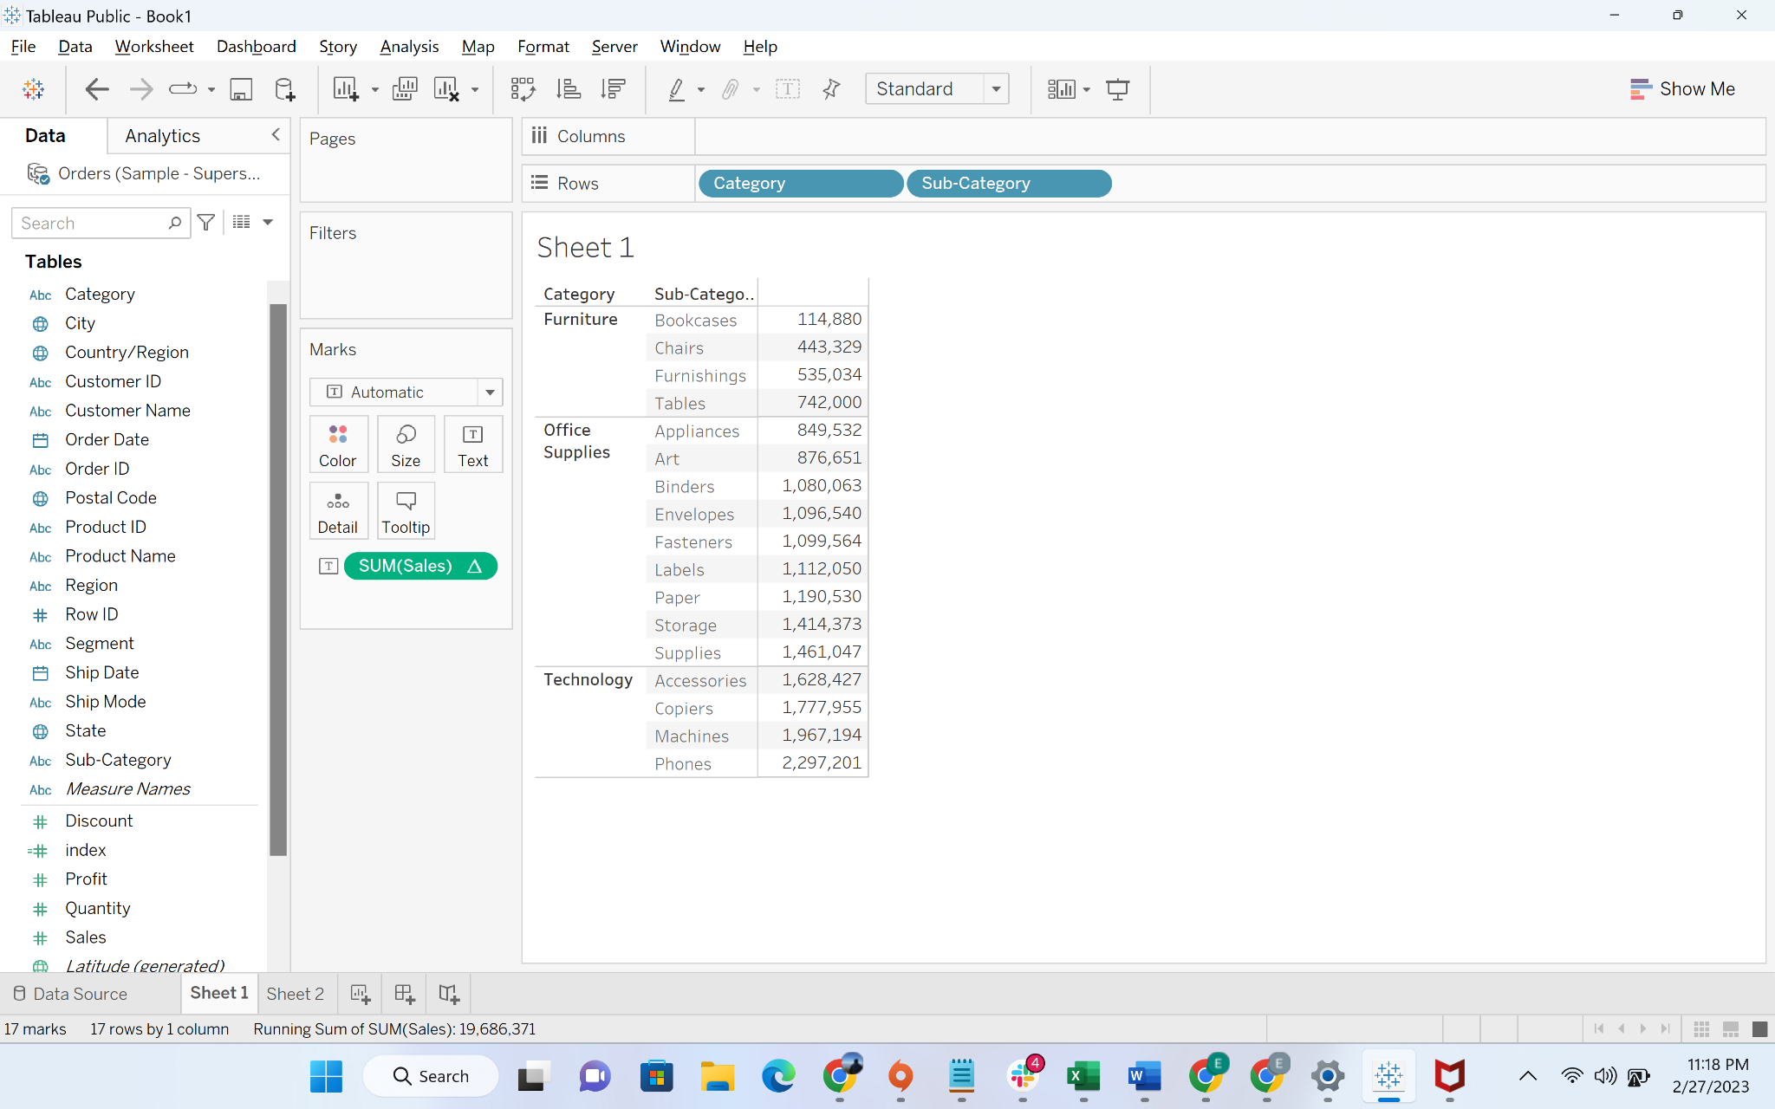

* Step-3: Drag the sales column again to “Text” Mark and you can see actual sales and cumulative sales

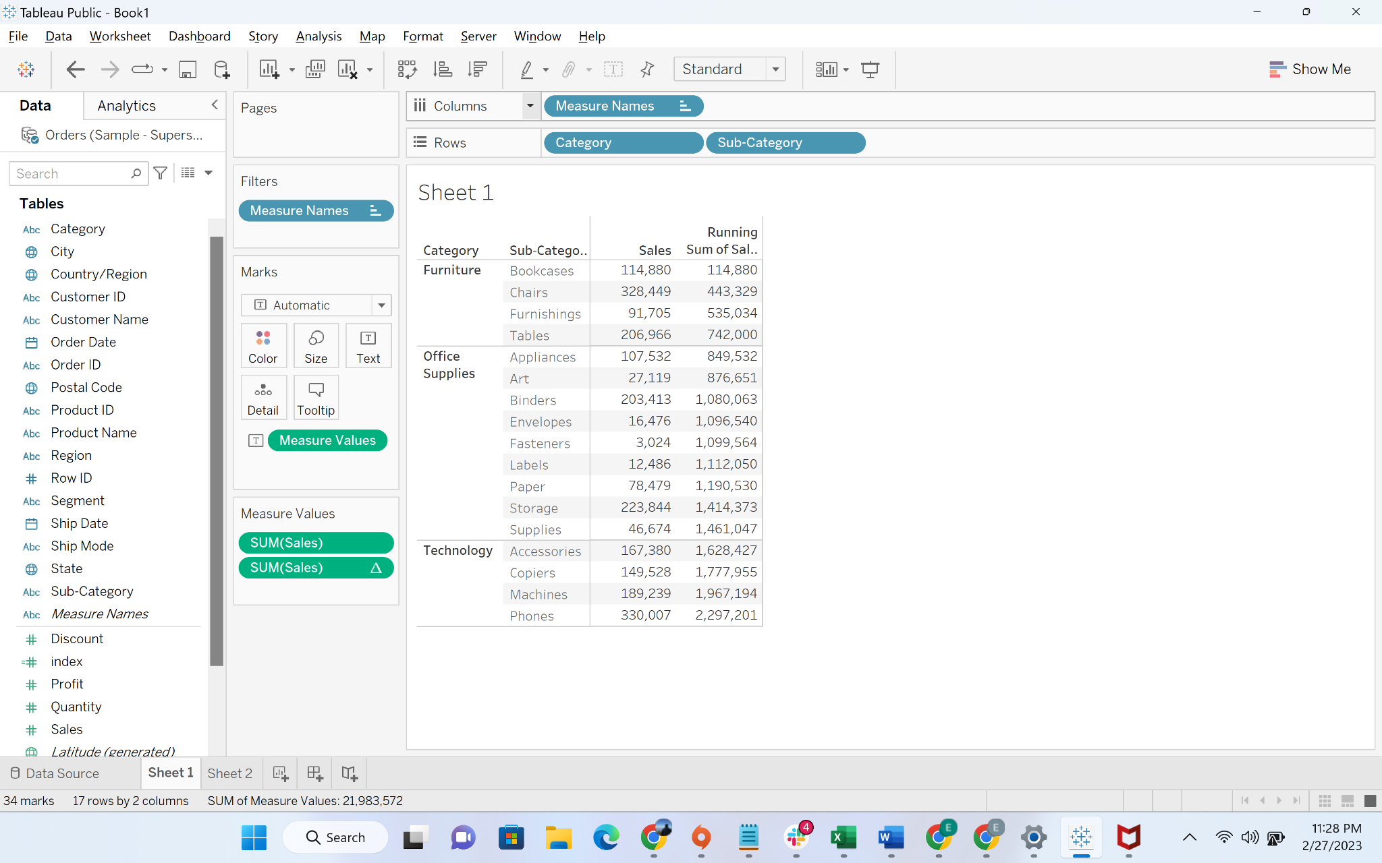

* Now let’s say we want to restart cumulative calculation at the start of each category. We can achieve this by following steps:
* Step-4: Click on the drop-down of sales with calculated field and go to “**Compute Using**” and then select “Pane Down”

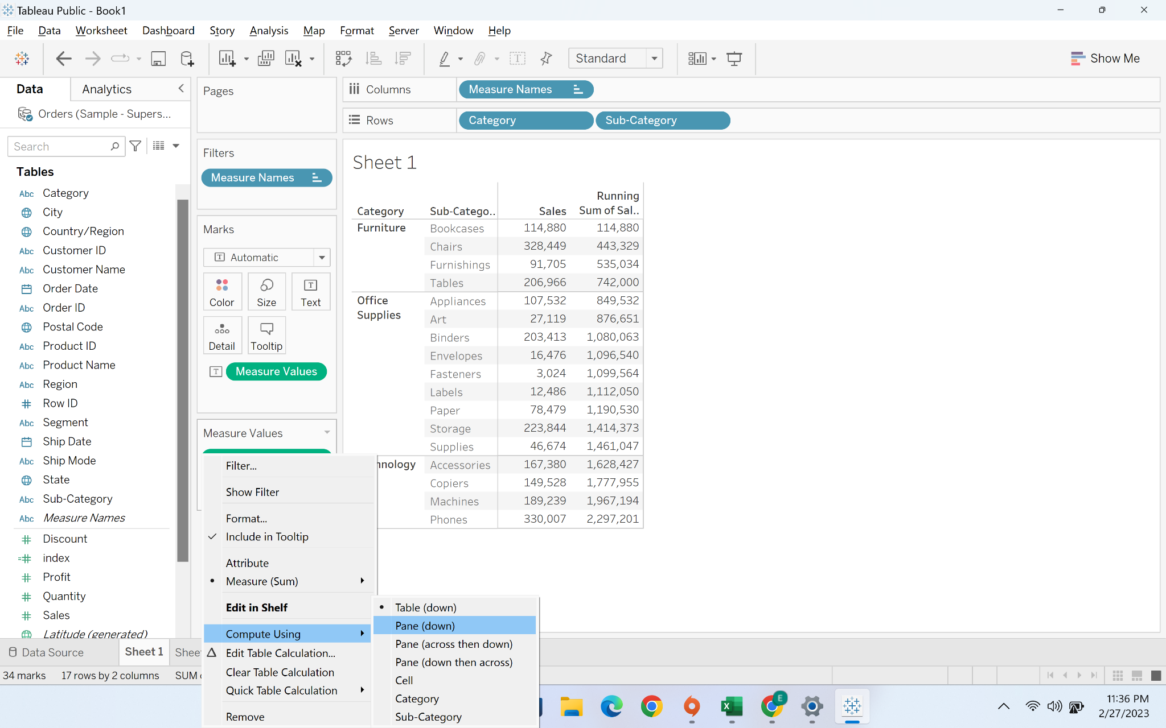

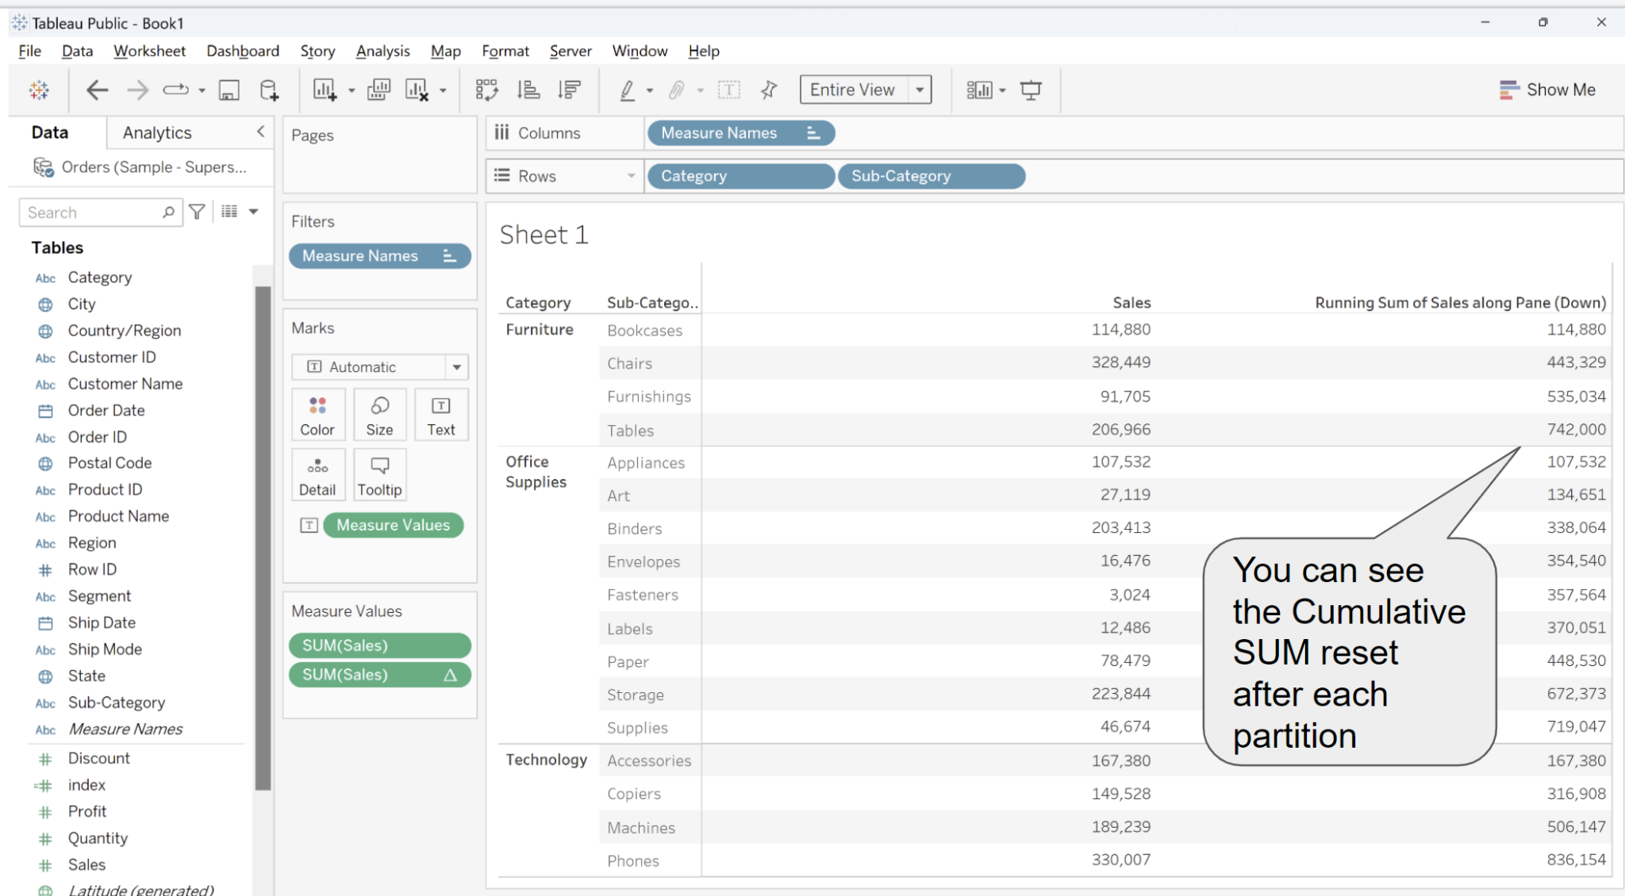

#### Understanding Table and Pane Option in Tableau:

* In the previous option, you have seen options like Table(down),pane(down), Pane(Across then down), Pane (down the across). We are now going to understand this in detail.

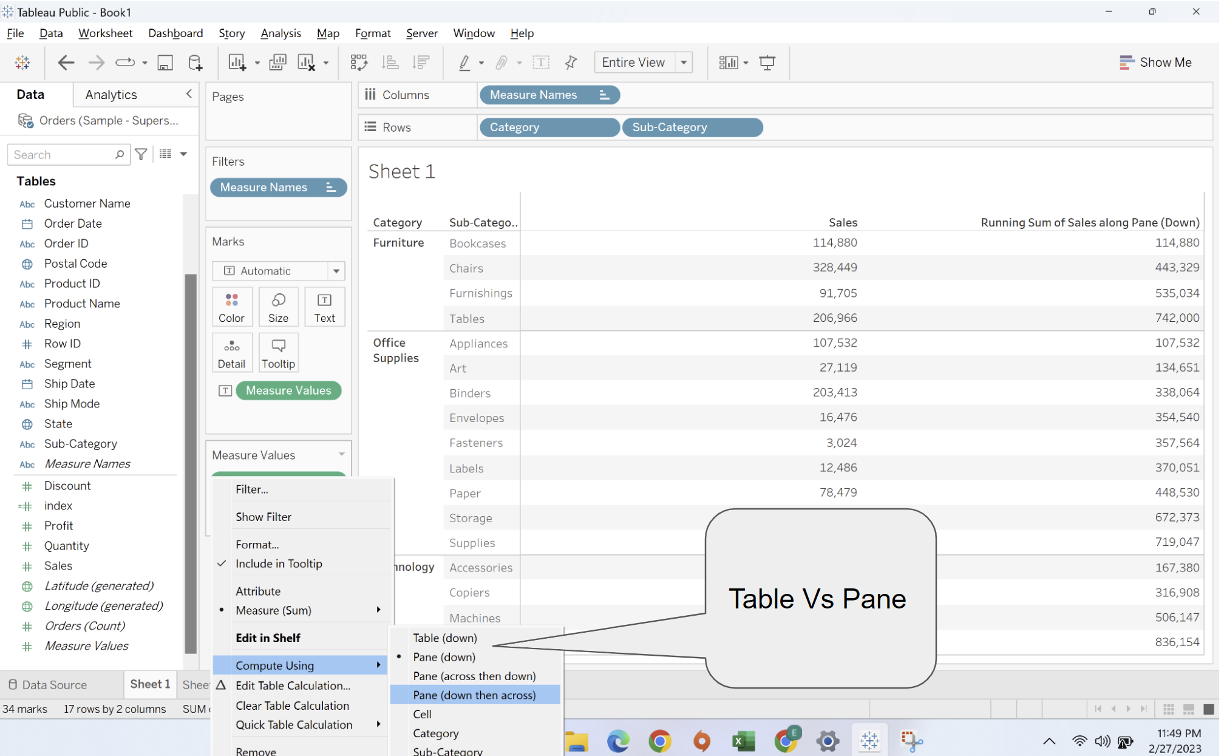

* In the previous option, you have seen options like Table(down) andpane(down). We are now going to understand this in detail.
* **Down** and **Across** are used to determine indexing. Indexing refers to assigning a relative position to a value compared to other values. Let’s understand through a demonstration.
* Let’s create a table by dragging **category, sub-category to rows and Region to column**

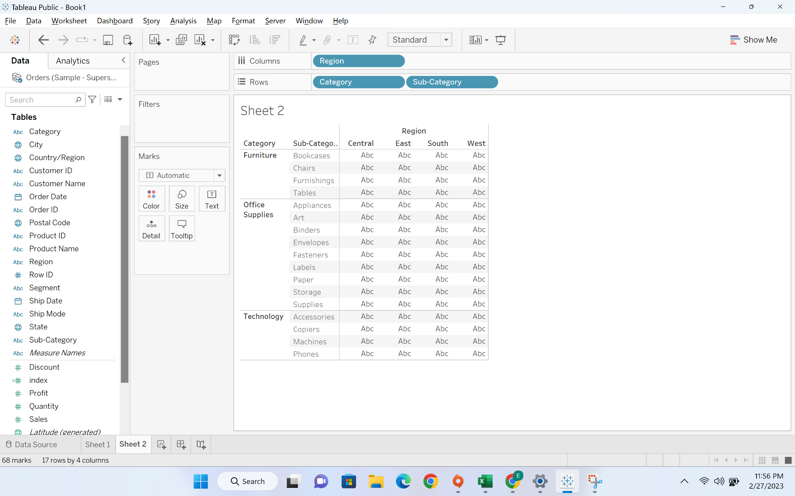

* Now we will create index using calculated field

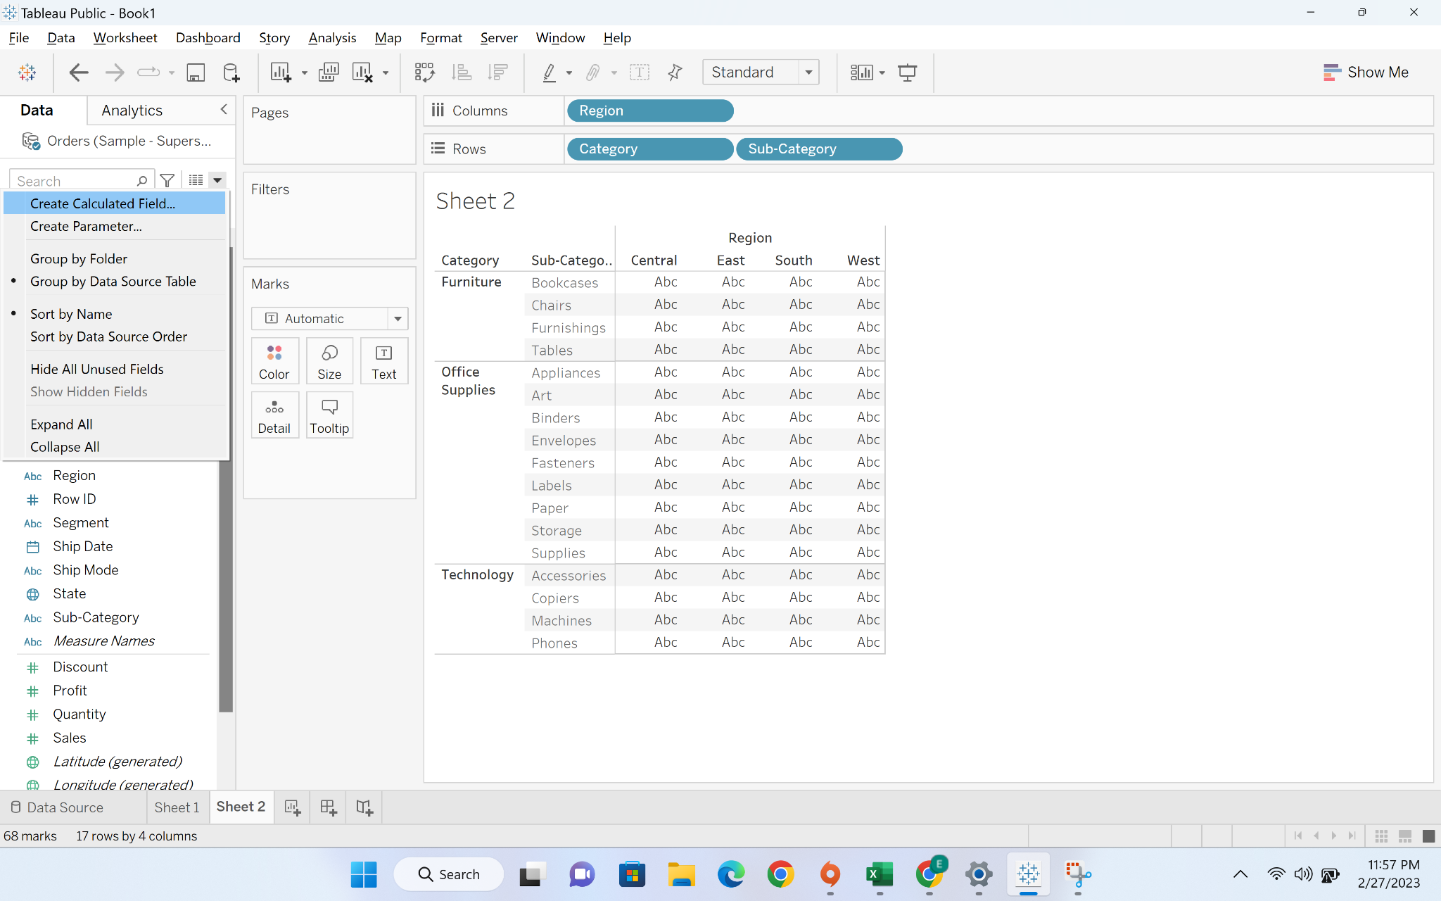

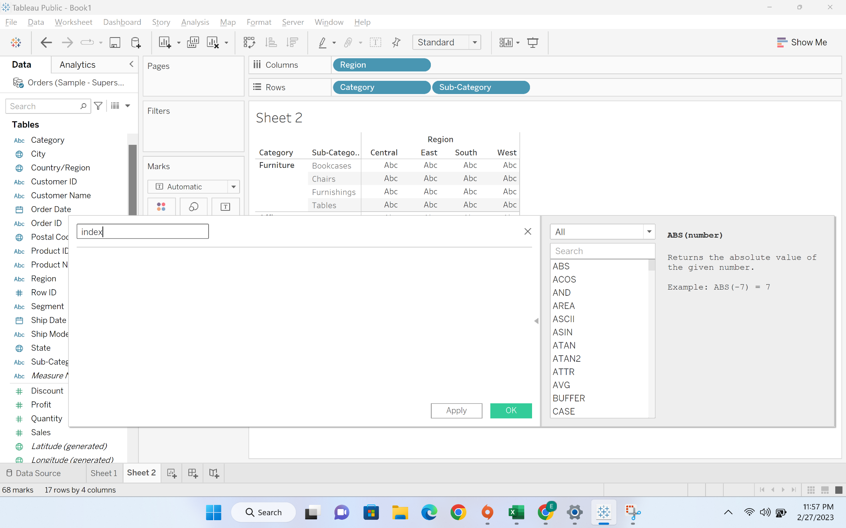

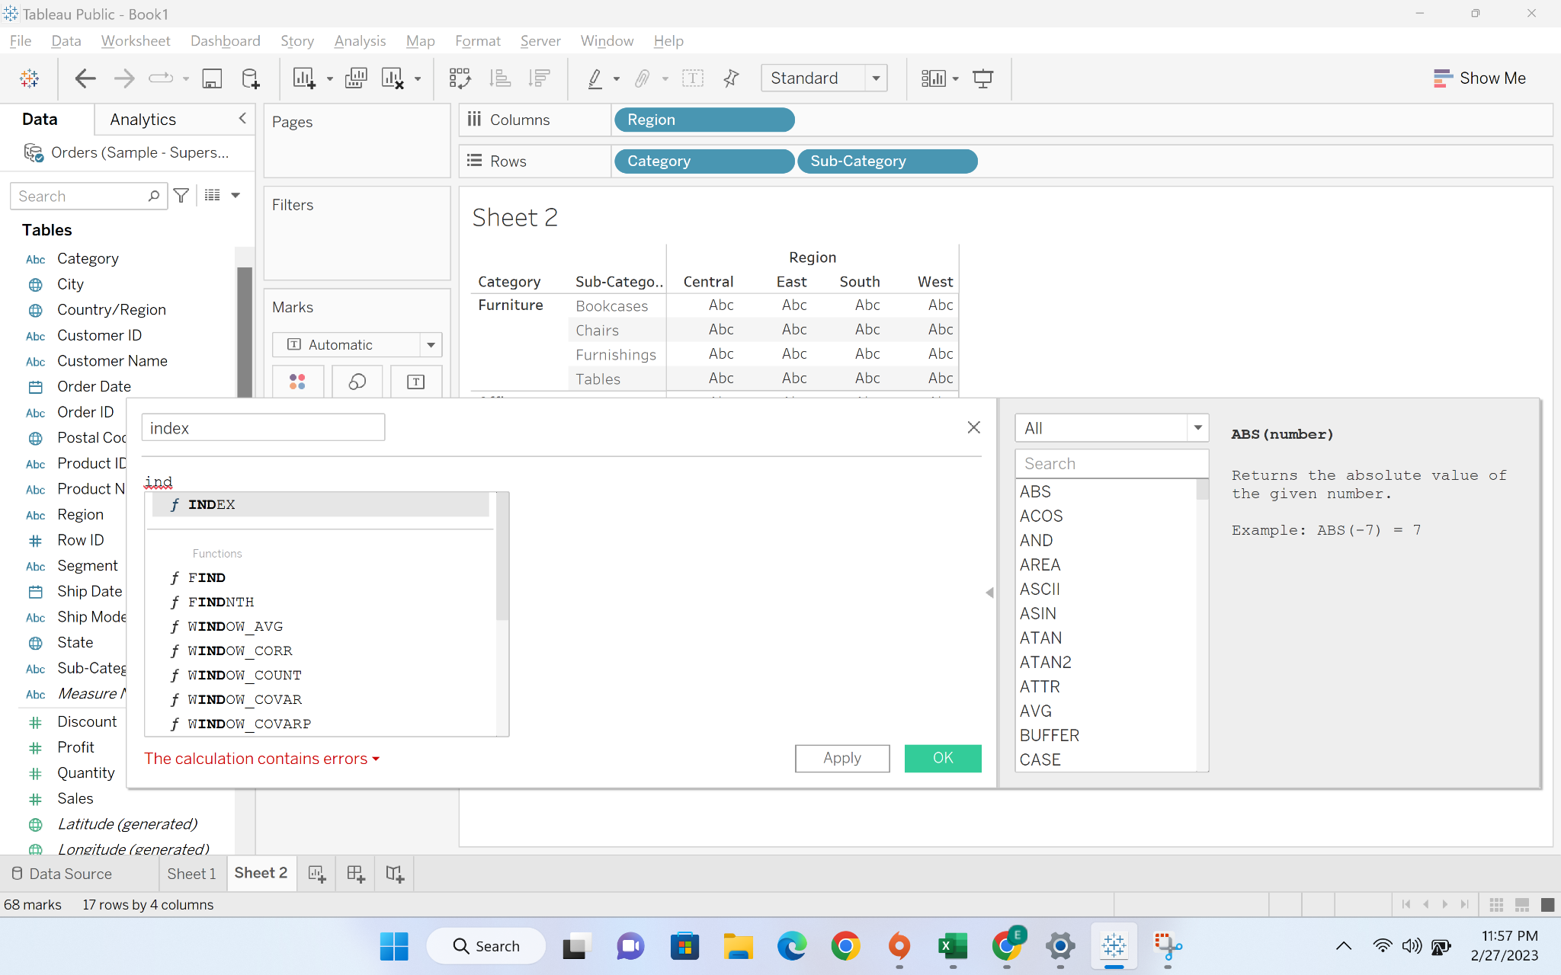

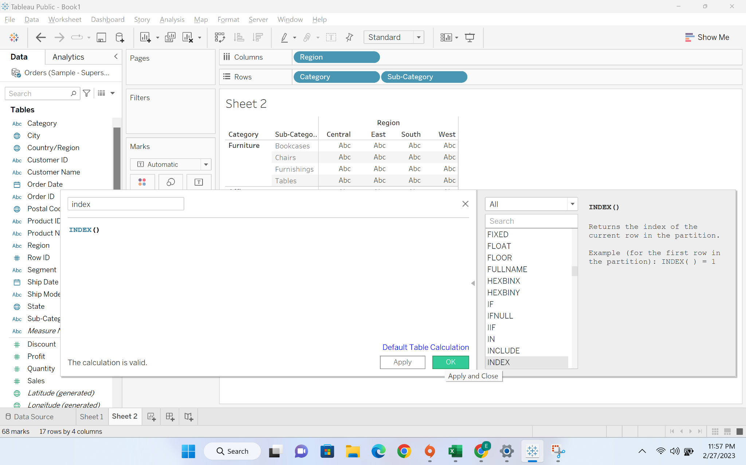

* Now we will drag index to the text

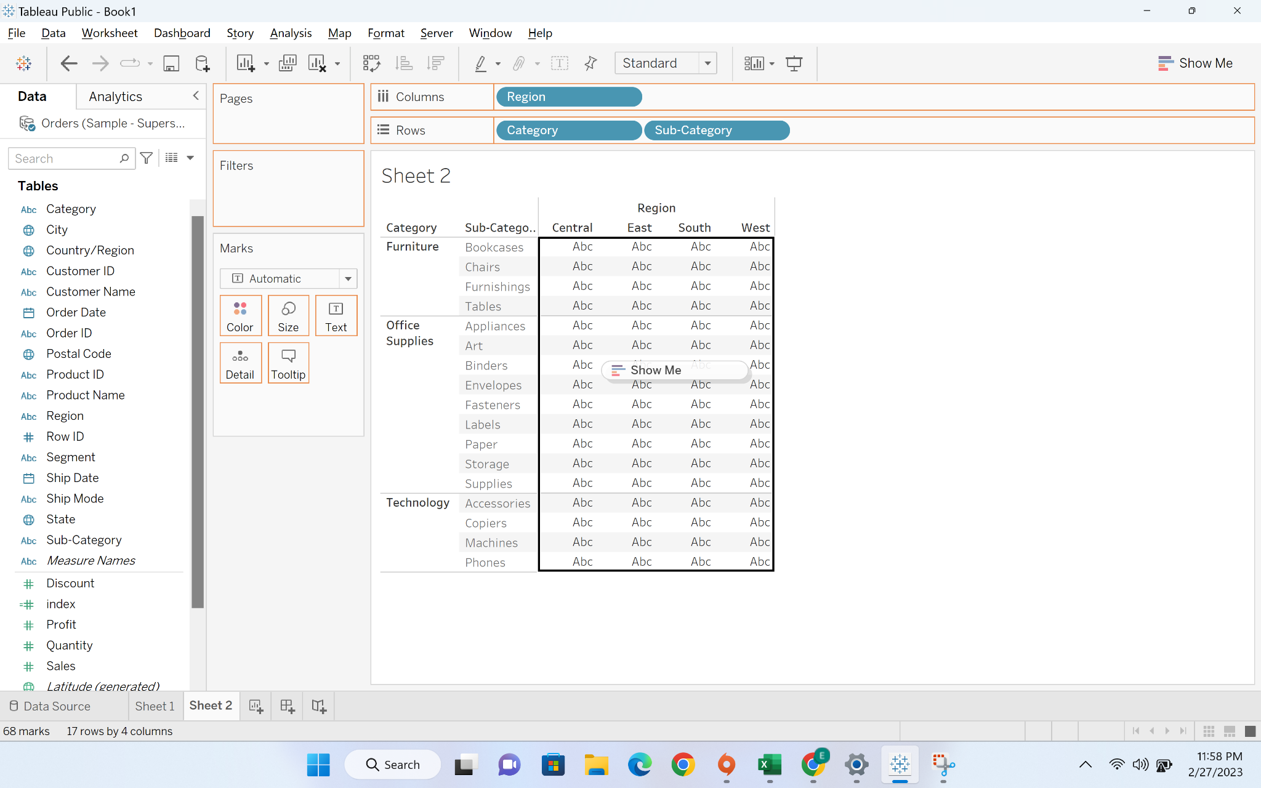

* We can see index are assigned to each value

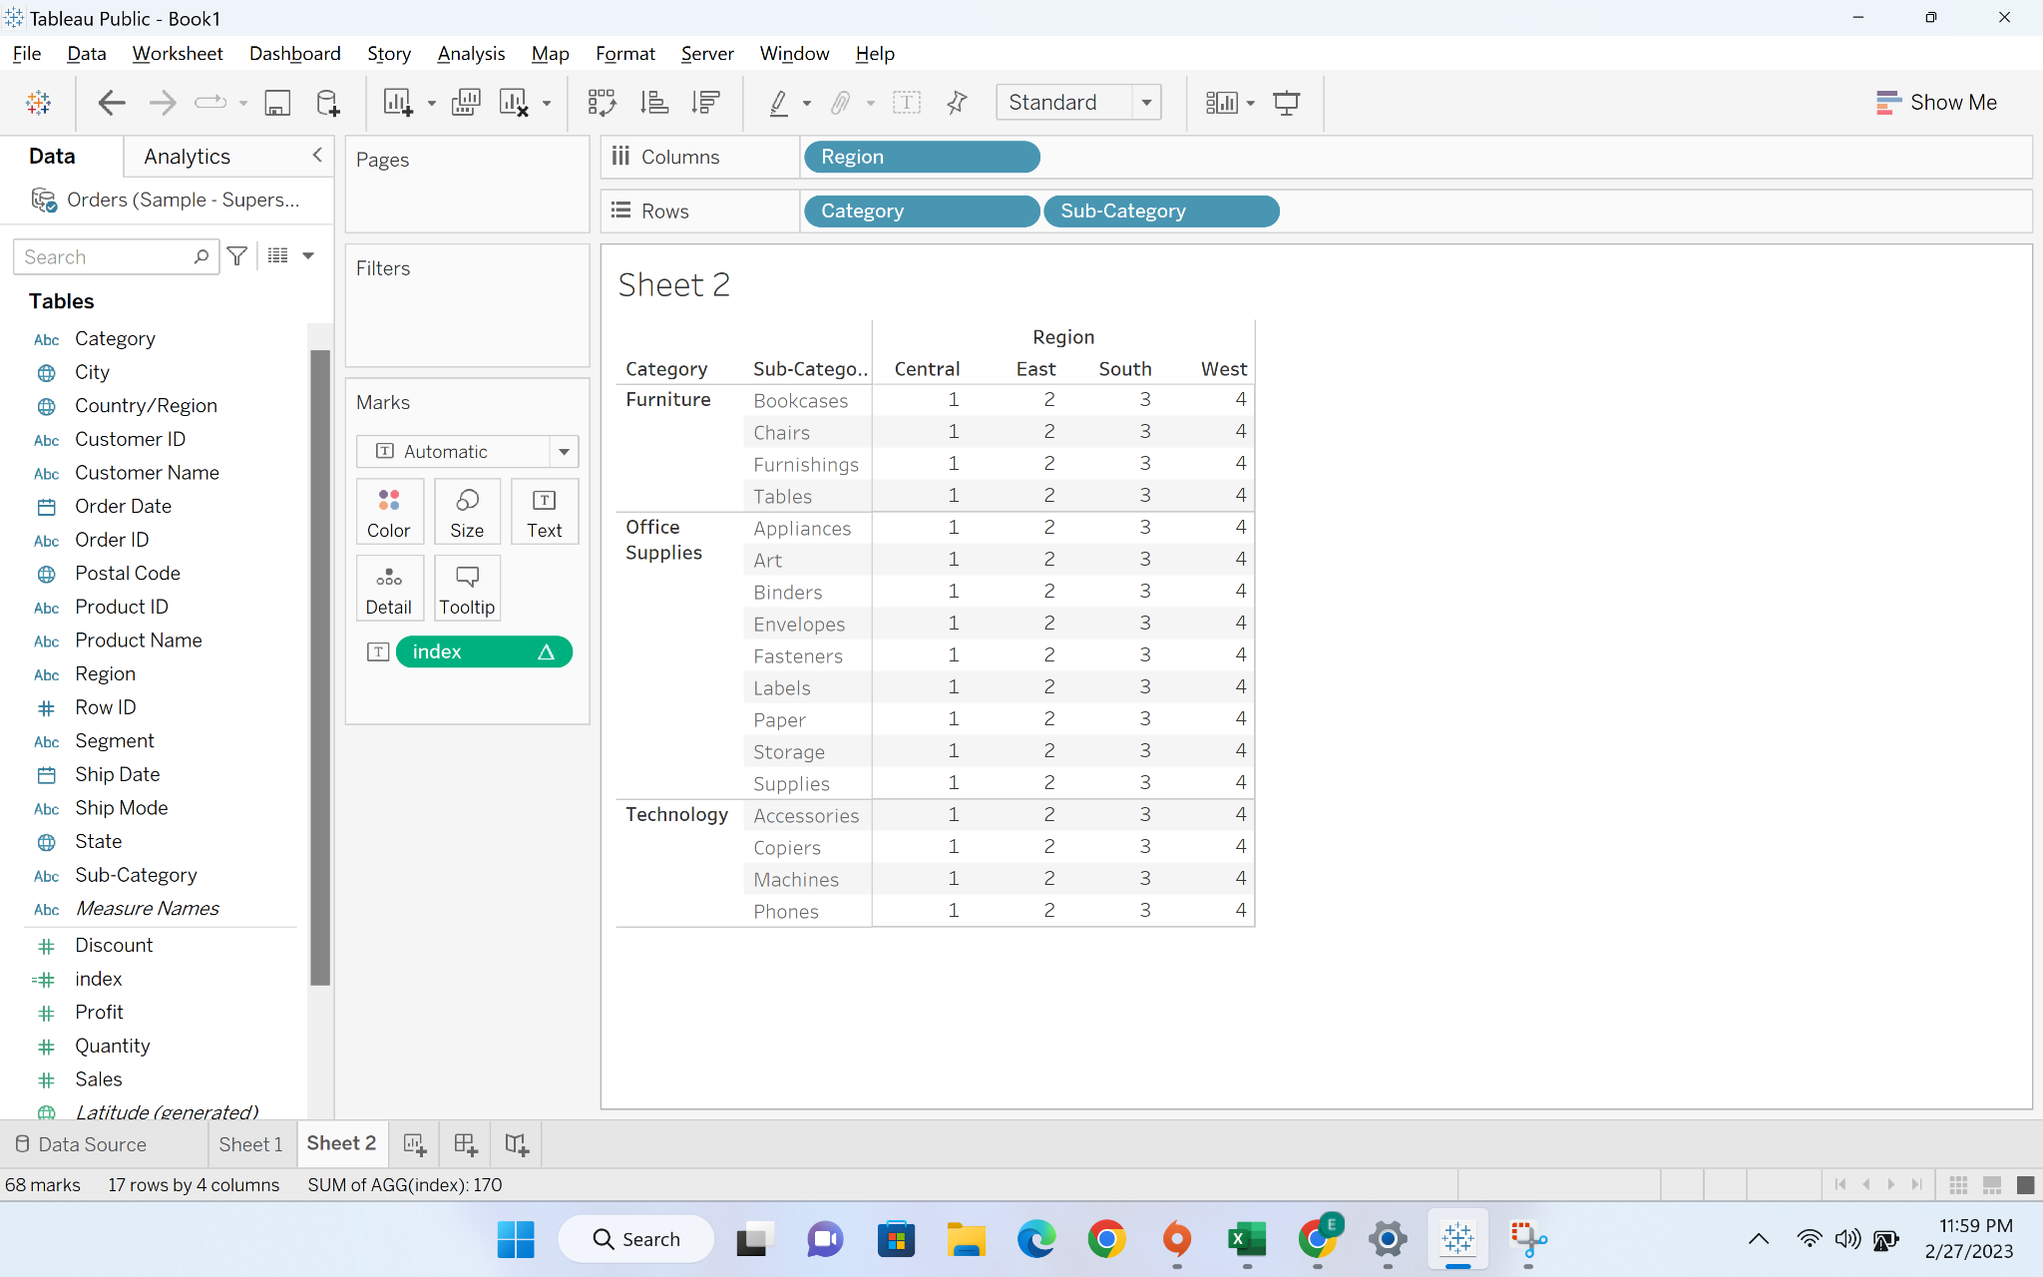

* Now we will go to “compute using” option and then we can play around with various options

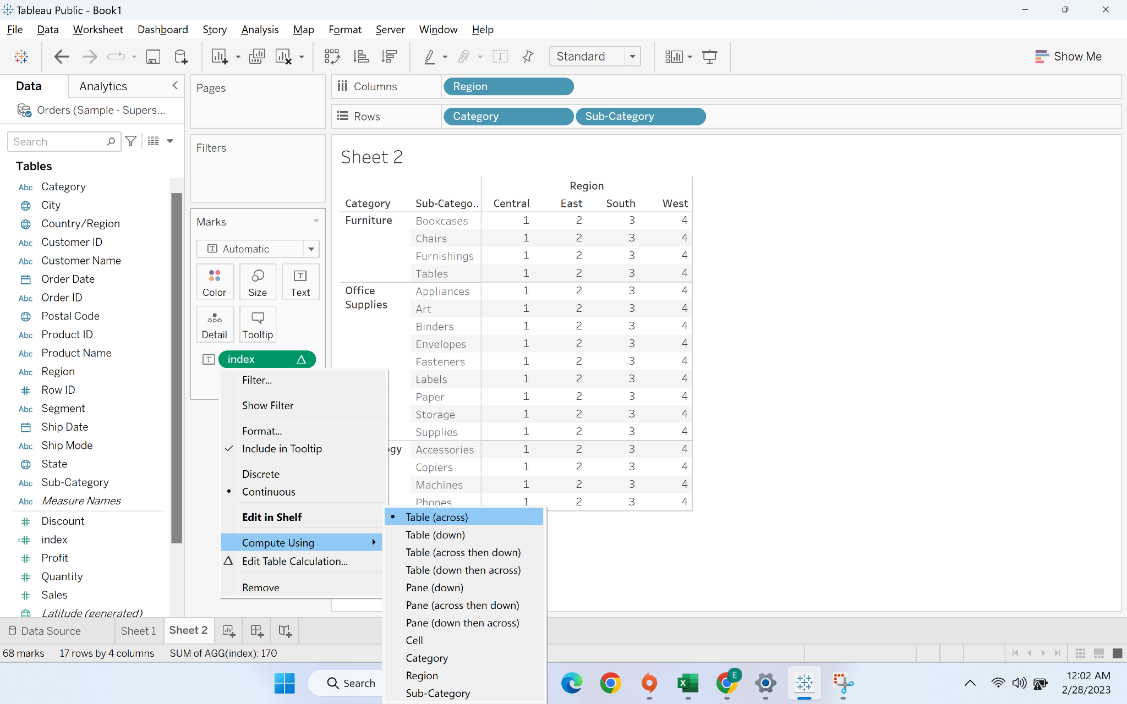

### 

#### **Business problem 1** -find percentage of total sales made per month for each year

Solution-1:

* Create a tabular view by dragging order date (and convert it into month) to rows and order date (and convert it to year) to columns

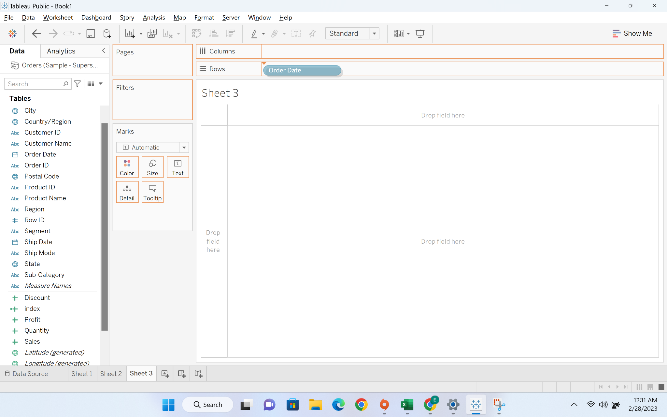

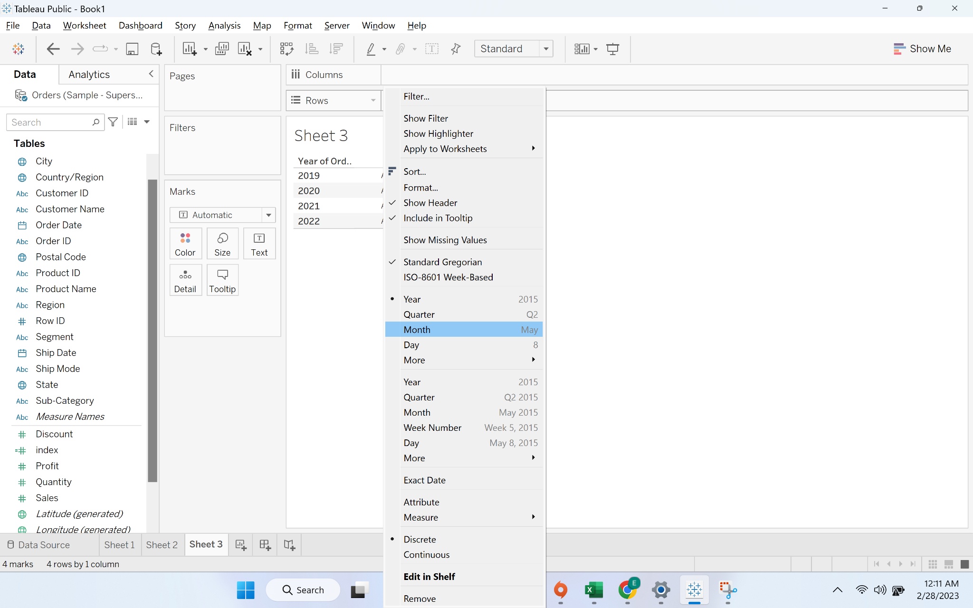

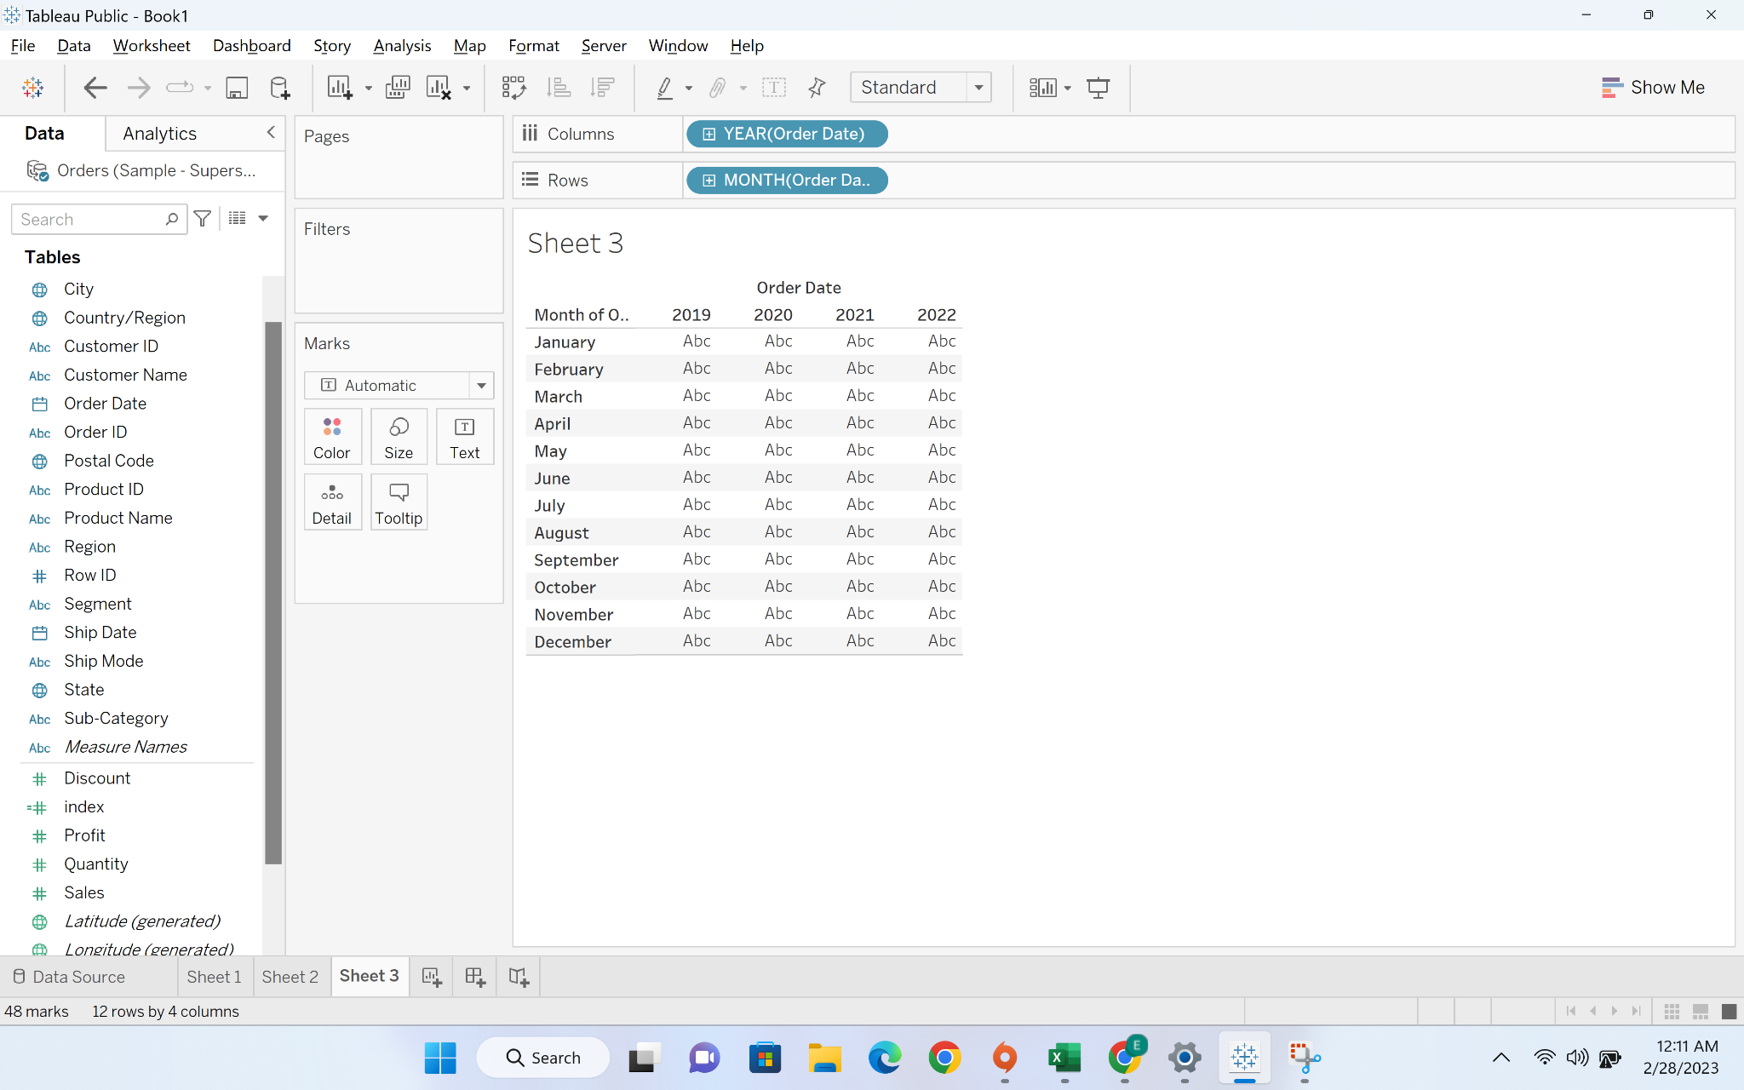

* Drag the sales to text

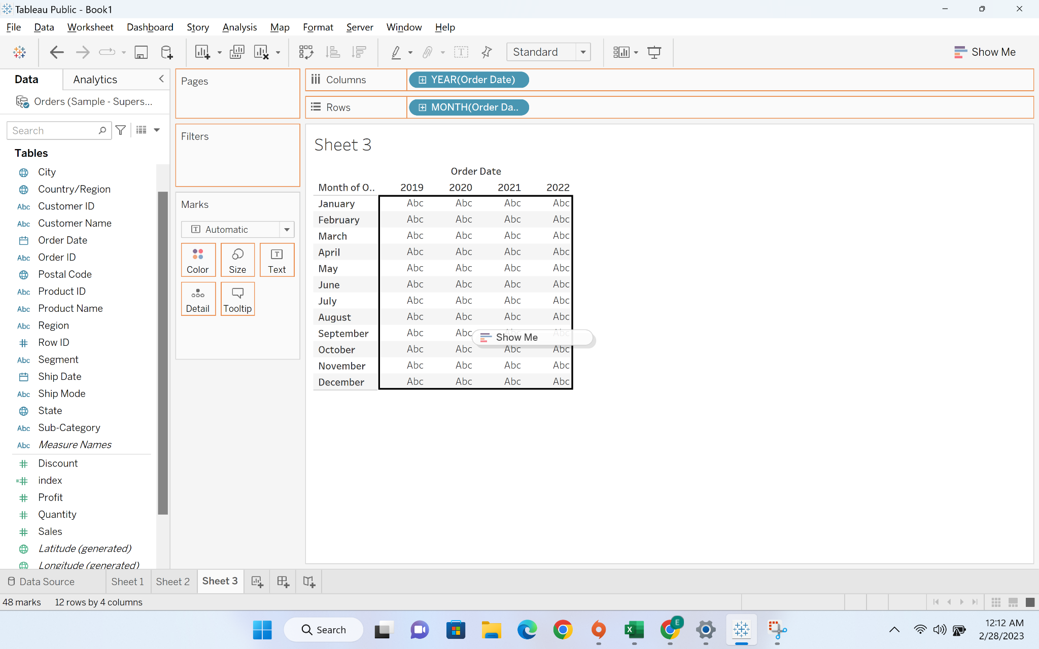

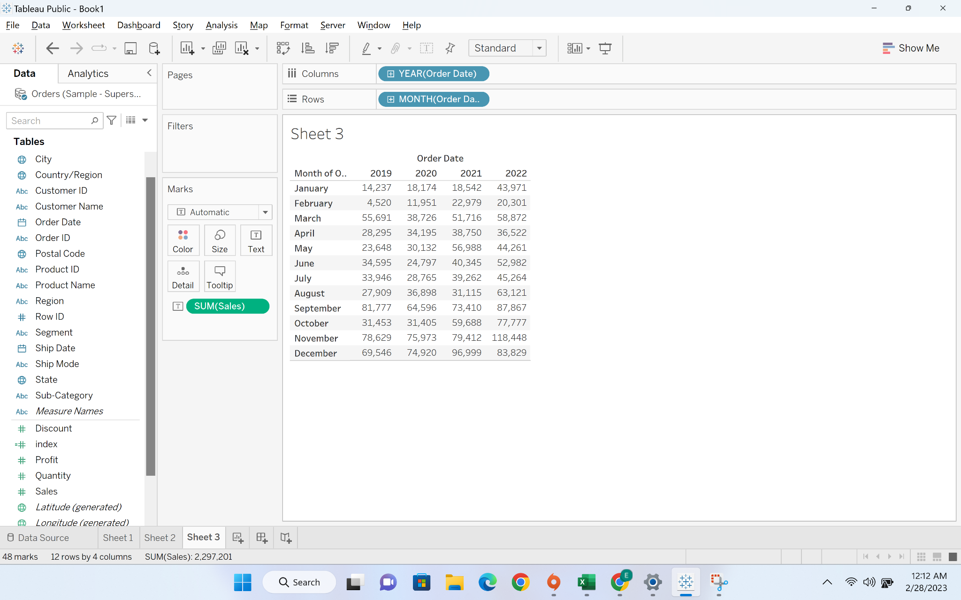

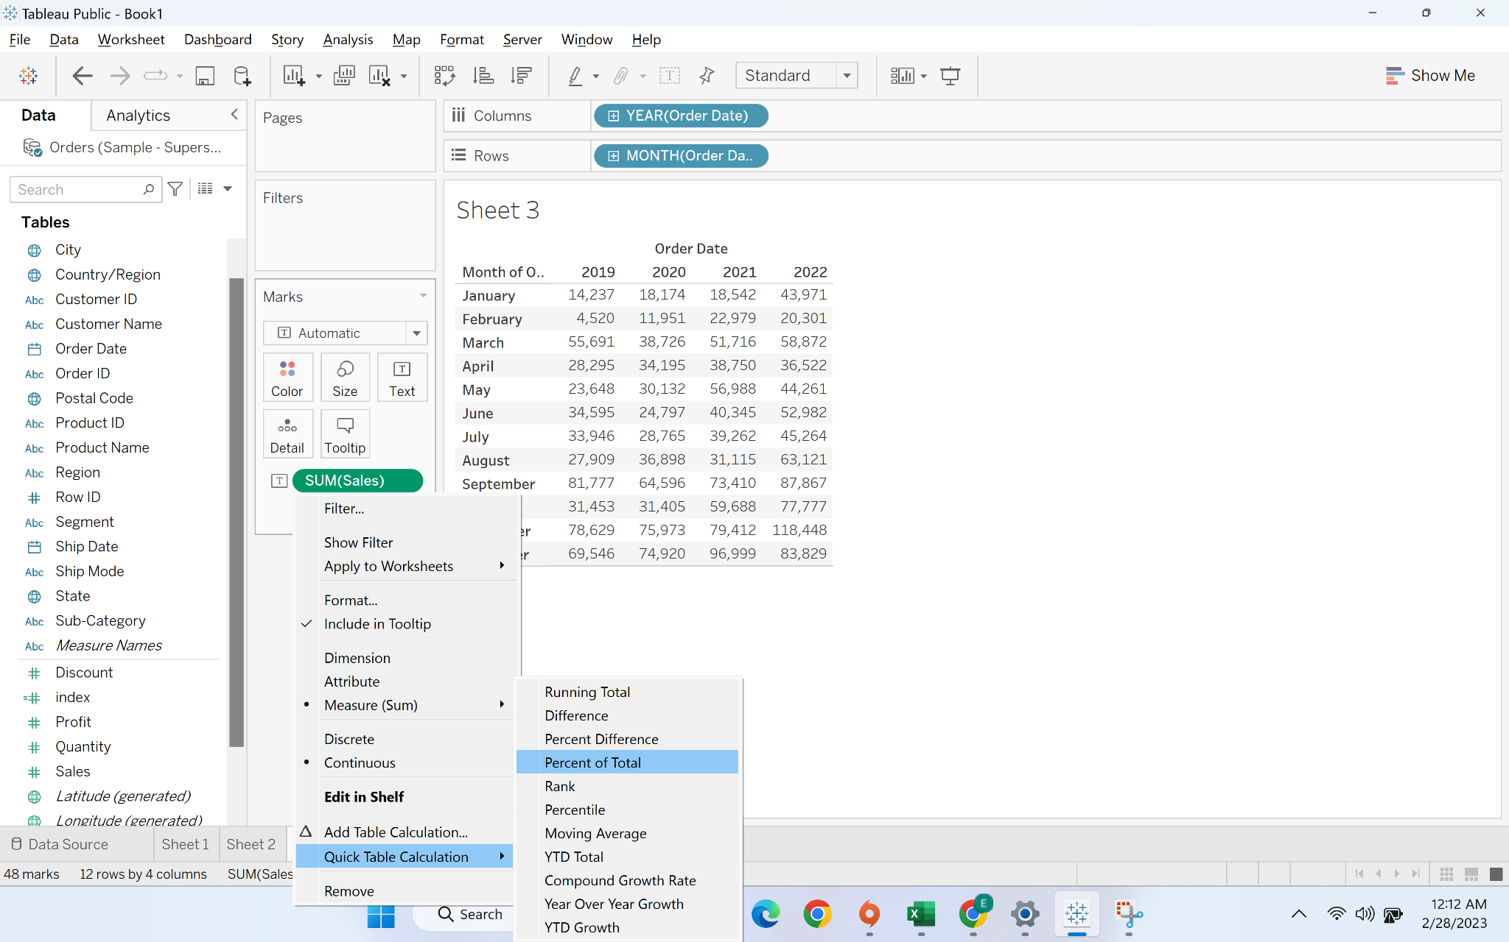

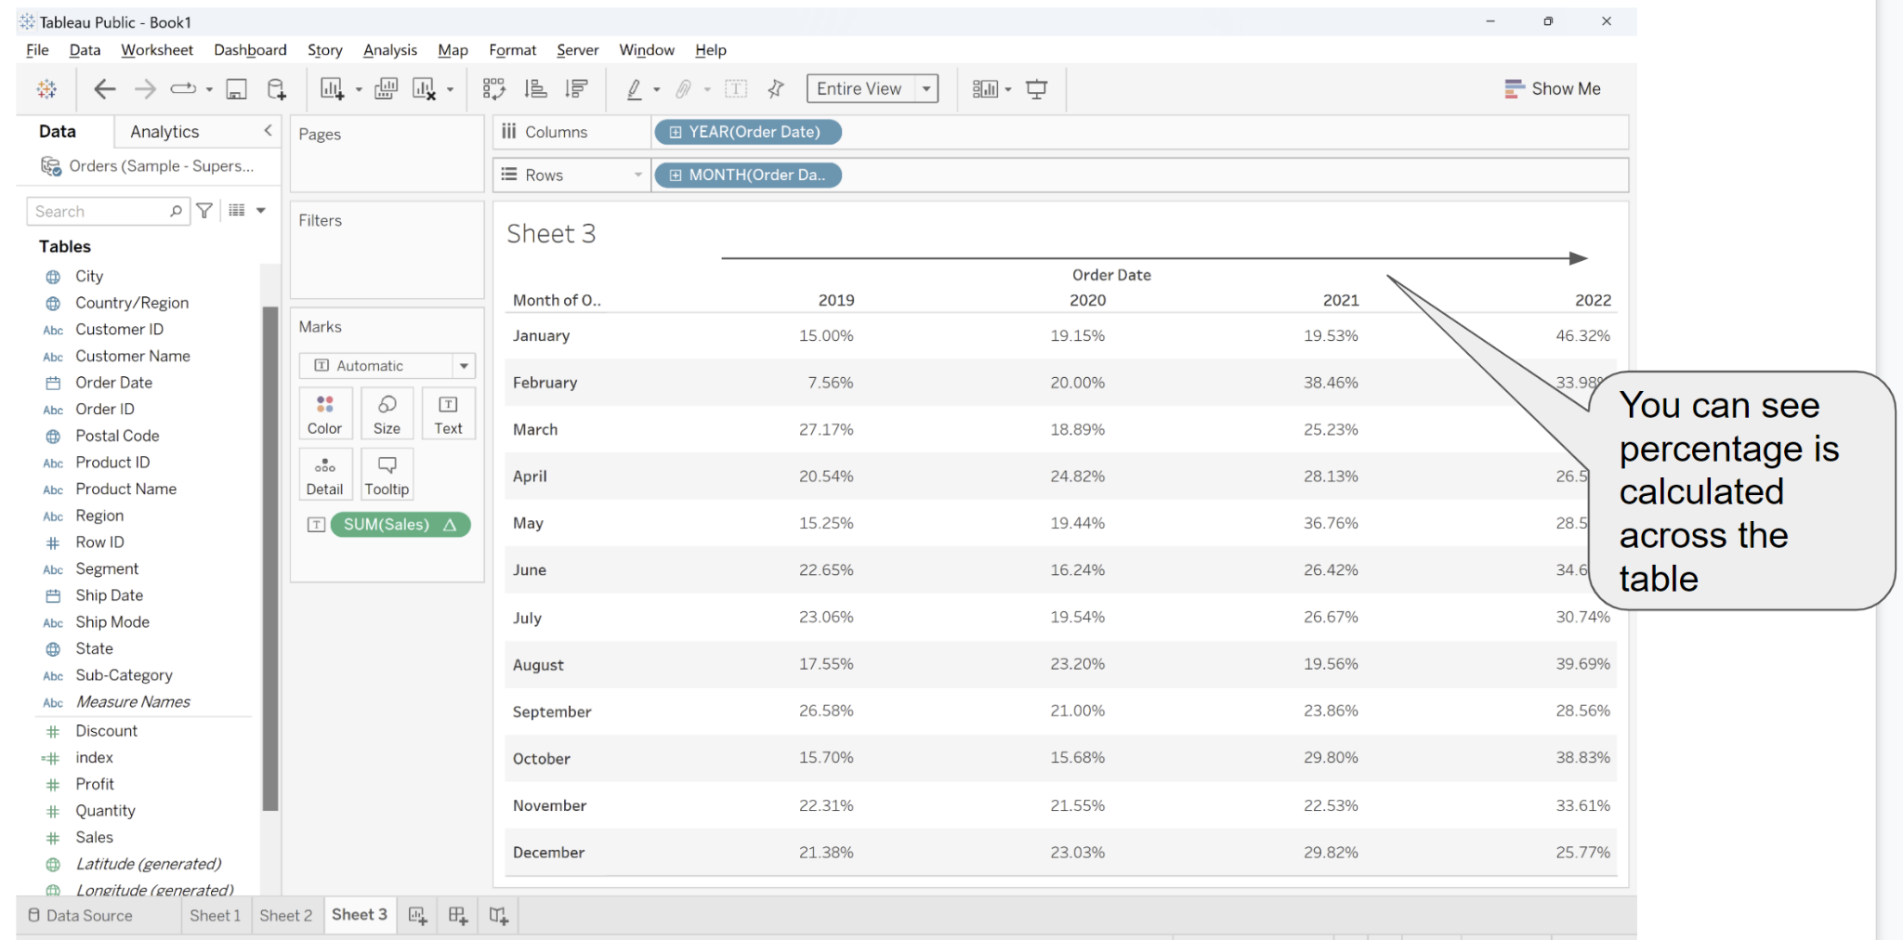

* We will change it from across the table to the entire table

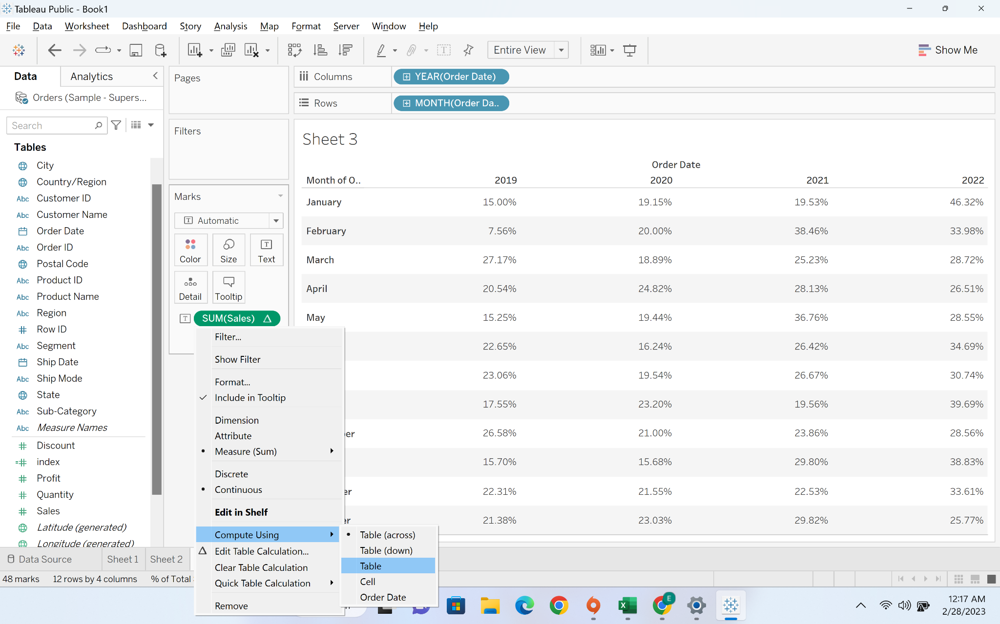

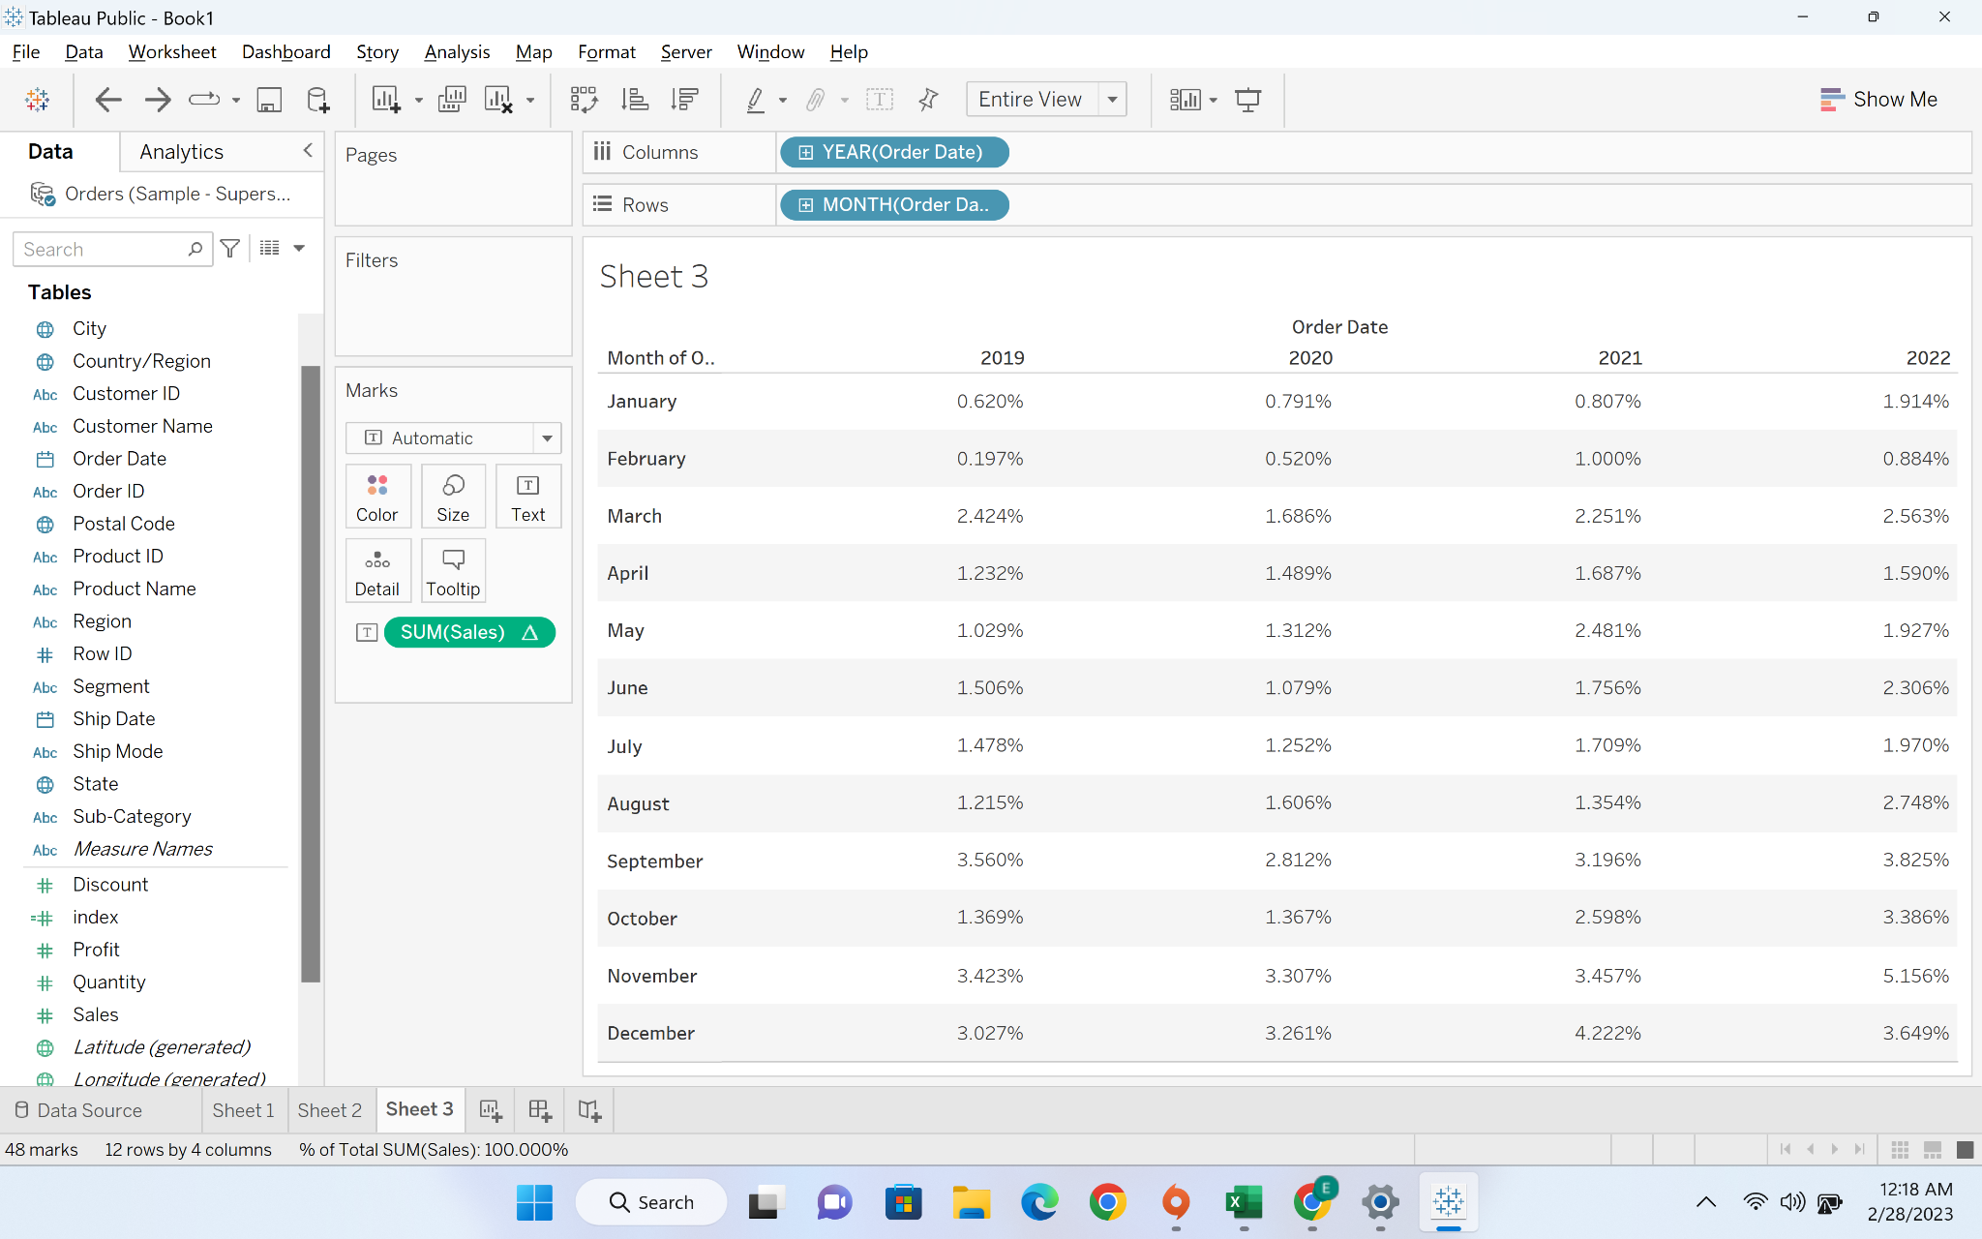

#### **Business problem 2**-find percentage of total sales done across different categories for each quarter of the given year

Solution-1:

* Create a tabular view with year and quarter in rows and category in column

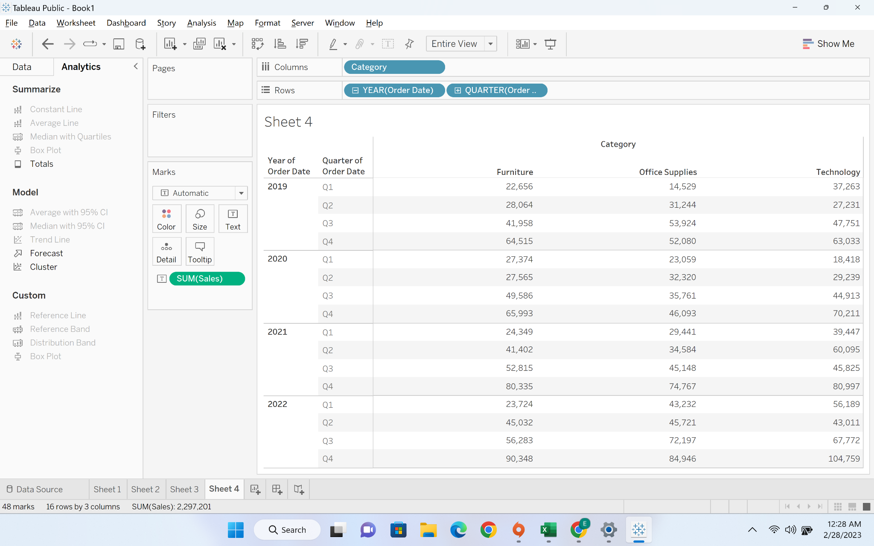

* We will now convert it into percentage

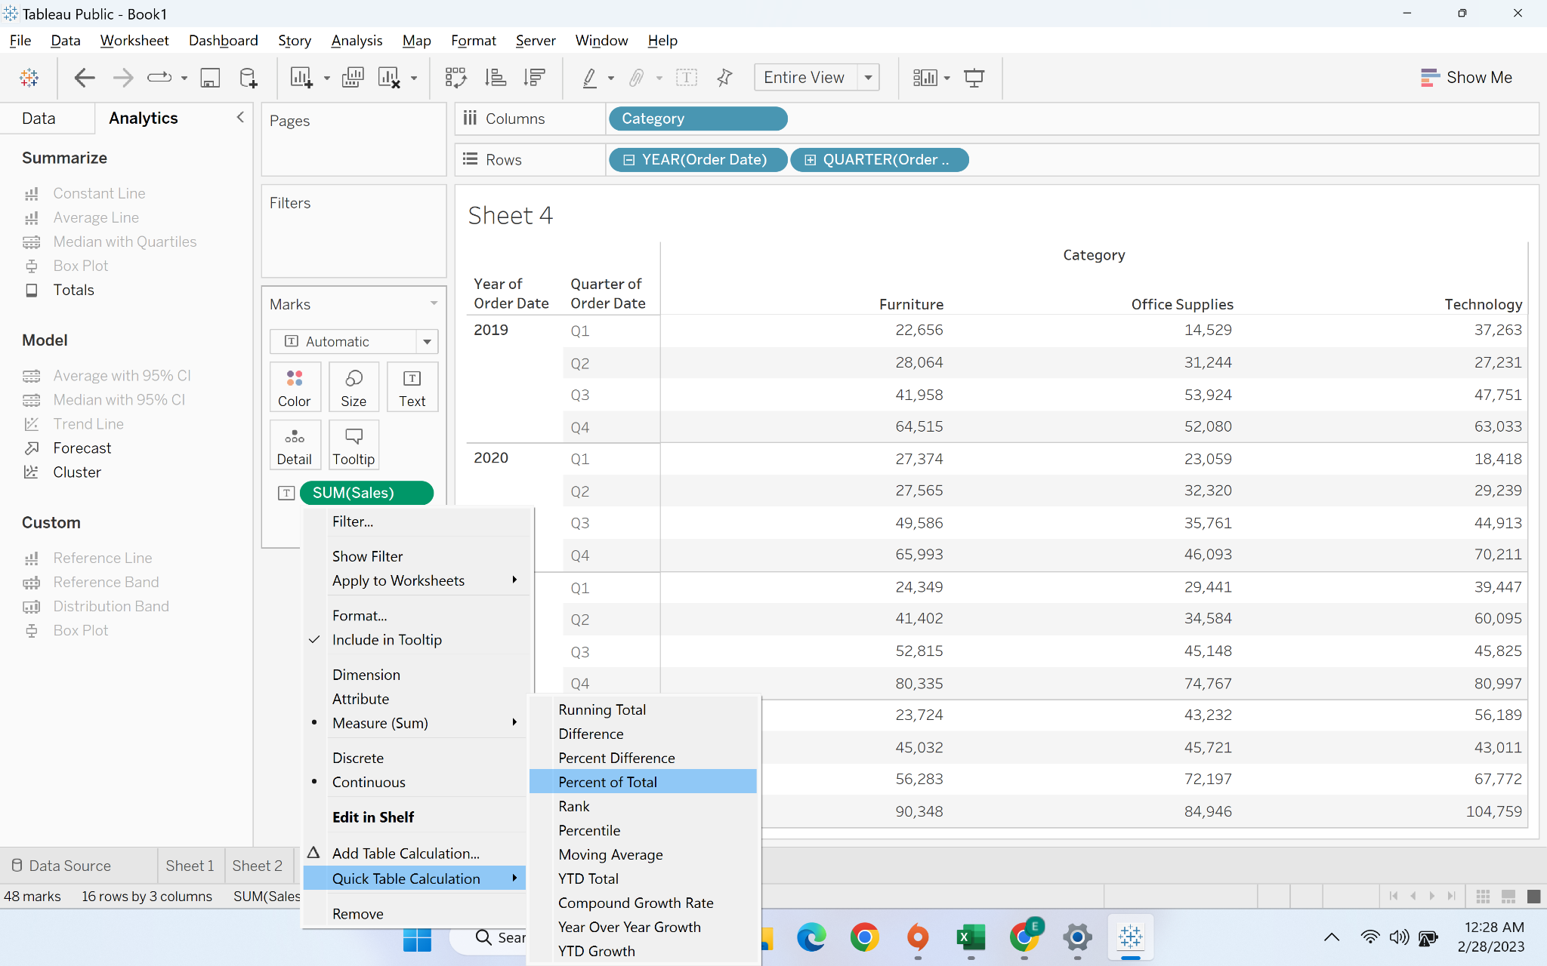

* We will now show the sub total and row wise percentage by using analysis tool at the top



 